Use the Employee Details dataset and perform the following activities: -

1. Split the column CITY and separate the code associate with each city like - Allahabad[AL2] should be only Allahabad and [A2] will be separate.

Ans: Refer Column City Name and City Code

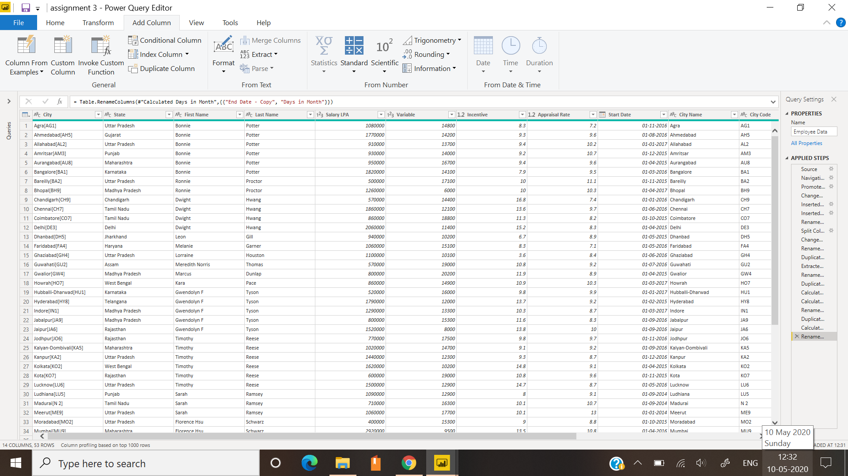

1. Extract the first name from EMPLOYEE NAME column and transform the column

Ans: Refer Column First Name and Last Name



1. Using the JOINING DATE column extract the Year and no. of days for that month.

Ans: Refer Column Year and Days in month

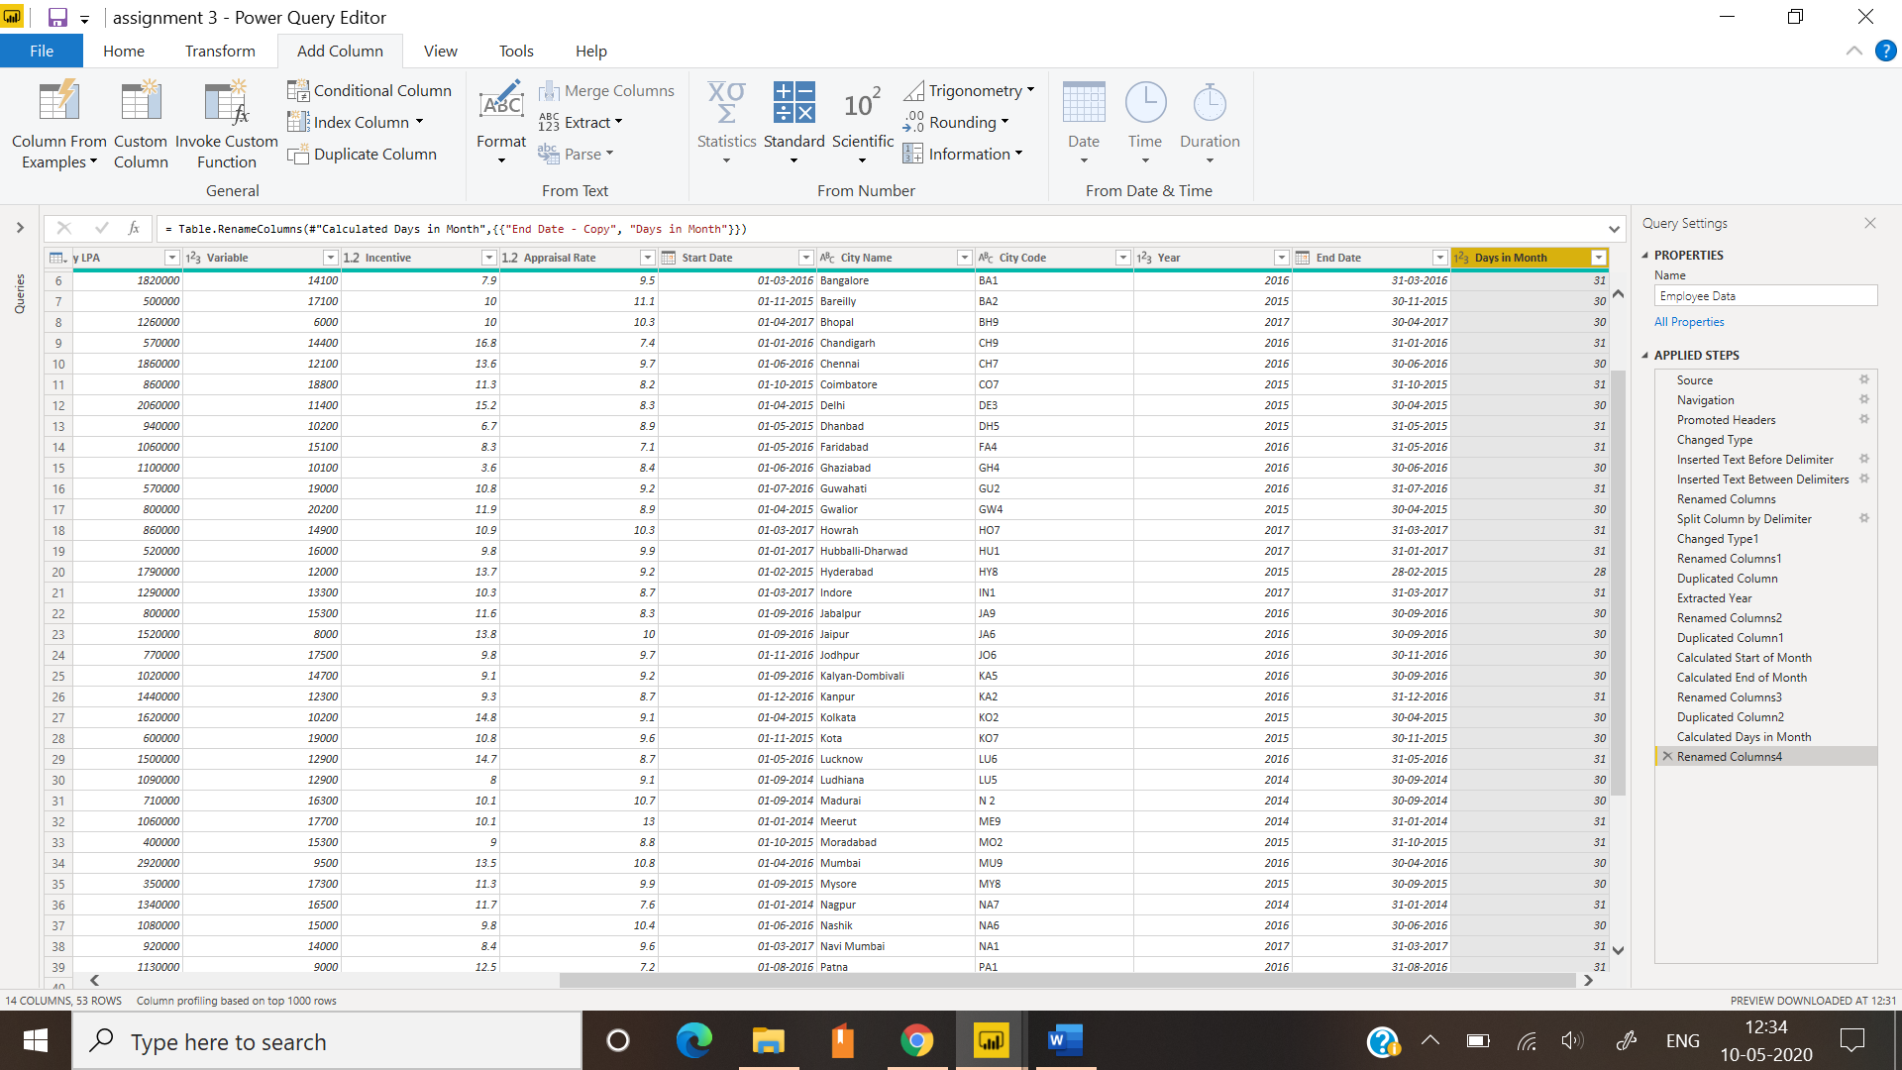

1. Create a visual of your choice and show the how much salary has been paid to each state and which state has lowest pay-out.

Ans: I created table for extracting how much salary is paid to each state and funnel to find out lowest pay-out as a % of total LPA. In this dataset, we have Assam and Chandigarh which have lower pay-outs.

